CAN2USB user reference

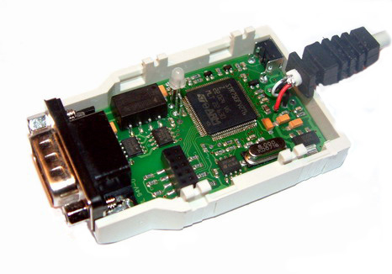

Preiminary version 0.0.1 2008-04-04 akhe@dofscandinavia.com

